
SRM Institute of Science and Technology
Mode of Exam
OFFLINE
College of Engineering and Technology
School of Computing
DEPARTMENT OF COMPUTATIONAL INTELLIGENCE
SRM Nagar, Kattankulathur – 603203, Chengalpattu District, Tamilnadu
Academic Year: 2022-23 (EVEN)
Test: CLAT-2 Date: 04.04.2023
Course Code & Title: 18AIC209T Foundation of Metric Spaces Duration: 1 Hour
Year & Sem: II Year & IV Semester Max. Marks: 25 Marks
Course Articulation Matrix: (to be placed)
Course Learning Outcomes (CO): |  |  |  |  |  | At the end of this course, learners will be able to:
CO-1 : |  | Discover whether examples of metric spaces are complete using Cauchy sequences
CO-2 |  | Understand iterative processes on general spaces
CO-3 |  | Can apply principles and algorithms to evaluate models generated from data
Program Learning Outcomes (PLO)
1 | 2 |  | 3 | 4 | 5 |  | 6 | 7 | 8 | 9 | 10 | 11 | 12 | PSO
Engineering Knowledge | Problem Analysis |  | Design & Development | Analysis, Design, Research | Modern Tool Usage |  | Society & Culture | Environment & Sustainability | Ethics | Individual &Team Work | Communication | Project Mgt. & Finance | Life Long Learning | PSO - 1 | PSO - 2 | PSO – 3
3 | 2 |  | 2 | 3 | - |  | - | 1 | - | - | 3 | 2 | 2 | 2 | 2 | 2
3 | 3 |  | 3 | 2 | 3 |  | - | 2 | 1 | - | 3 | 3 | 2 | 2 | 2 | 2
3 | 3 |  | 2 | 3 | 3 |  | 2 | 2 | 2 | 1 | 3 | 2 | - | 2 | 2 | 2

Part - A
( 10 x 1 = 10 Marks)
Instructions: Answer all
Q. No | Question | Marks | BL | CO | PO | PI Code
1 | If for A ⊆ (X, d), ∃ an open ball B(x; r) ∀ x ∈ A contained in A , then A is called ________  (a)Open Set  (b)Open Ball  (c)Open Interval  (d)Neighborhood | 1 | 1 | 2 | 1,2 | 1.1.1
2 | Which one is not an open set?  (a)(a, b)  (b)(a, b]  (c)∅  (d)(a, b) U (c, d) | 1 | 1 | 2 | 1,2 | 1.1.2
3 | If (X, d) is a metric space. Then  (a)∅ is open  (b)X is open  (c)X is non-empty  (d) only empty | 1 | 1 | 2 | 1 | 2.1.1
4 | In a discrete space (X, d), every subset is _______  (a)Open Set  (b)Open Ball  (c)Open Interval  (d)Neighborhood | 1 | 1 | 2 | 1,2 | 2.1.3
5 | A point x of A is an interior point of A if for some r > 0, ∃ an open ball B(x; r) such that  (a)x ∈ B(x; r) ⊆ A  (b)x ∉ B(x; r) ⊆ A  (c)x ∈ B(x; r) ⊇ A  (d) x ∉ B(x; r) ⊇ A | 1 | 1 | 2 | 1,2 | 2.1.3
6 | The set X makes a ______ metric space under the metric defined by  𝑑(𝑥, 𝑦) = {1 𝑖𝑓 𝑥 ≠ 𝑦  0 𝑖𝑓 𝑥 = 𝑦  (a)Discrete  (b)Bounded  (c)Continuous  (d) Indiscrete | 1 | 1 | 3 | 1,2 | 1.4.1
7 | Which one represents triangular inequality?  (a)d(x, y) + d(y, z) ≤ d(x, z)  (b)d(x, y) + d(y, z) ≥ d(x, z)  (c)d(x, y) + d(y, z) > d(x, z)  (d)d(x, y) + d(y, z) < d(x, z) | 1 | 1 | 3 | 1,2 | 1.1.1
8 | In a topological space (X,τ), the members of τ are called __________  - Open sets  (a)Open sets  (b)Closed sets  (c)Topology members  (d)None of the above | 1 | 1 | 3 | 1 | 2.1.1
9 | The topology of a set containing only ∅ and the set itself is called _________  (a)Discrete topology  (b)Indiscrete topology  (c)Trivial topology  (d) Order Topology | 1 | 1 | 3 | 1 | 1.2.2
10 | If X is a set and τ is a topology on X then (X, τ) is called _________  (a)τ-Topological space  (b)Discrete topological space  (c)Indiscrete topological space  (d) Simple topological space | 1 | 1 | 3 | 1,2 | 1.1.1
Part – B ( 3 x 5 = 15 Marks)
Instructions: Answer any 3

11 | Show that if (X,d) and are isometric, then they are homeomorphic. | 5 | 3 | 2 | 1,2 | 2.4.1
12 | Let X be any non-empty set and d be the discrete metric defined on X. Prove that the metric space (X,d) is a complete metric space. | 5 | 3 | 2 | 1,2 | 2.4.1
13 | Describe topology on a set X with properties. | 5 | 2 | 3 | 1,2 | 2.3.1
14 | Give brief notes on the Hausdorff metric with an example. | 5 | 2 | 3 | 1,2 | 2.3.2

*Performance Indicators are available separately for Computer Science and Engineering in AICTE examination reforms policy.
Course Outcome (CO) and Bloom’s level (BL) Coverage in Questions

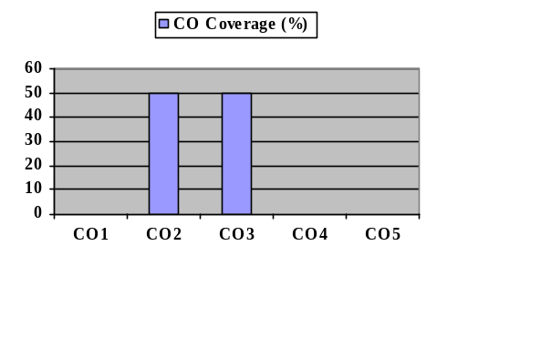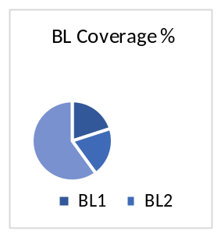
Approved by the Audit Professor/Course Coordinator

